**AXIAL FLOW INDUSTRIAL FANS:**

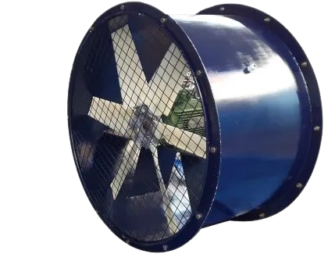

**Price: 14,000.00**

The Axial Flow Industrial Fan is a high-performance ventilation solution, designed to provide efficient and powerful airflow in demanding industrial environments. With its robust axial flow design, this fan delivers high-volume air movement, making it perfect for factories, warehouses, and large commercial spaces. Its heavy-duty construction, adjustable speed settings, and energy-efficient motor ensure reliable operation, reduced energy costs, and improved air quality, making it an ideal choice for industrial ventilation needs.

**Key features of axial flow industrial fans include:**

* **High Airflow Capacity**: Moves large volumes of air efficiently.
* **Durable Construction**: Built for heavy-duty industrial use.
* **Energy Efficient**: Optimized for low power consumption.
* **Compact Design**: Space-saving with effective cooling.
* **Versatile**: Suitable for various industrial applications.
* **Adjustable Speed**: Customizable airflow for specific needs.